

CCT College Dublin Continuous Assessment

Programme Title: | MSc in Data Analytics
Cohort: | MSc in Data Analytics FT (Feb 26 start)
Module Title(s): | Advanced Data Analytics  Big Data Storage and Processing
Assignment Type: | Individual | Weighting(s): | Advanced Data Analytics – 40%  Big Data Storage and Processing – 40%
Assignment Title: | Integrated CA1 Sem 2 MSc in Data Analytics
Issue Date: | 7th September 2026
Lecturer(s): | David McQuaid Muhammad Iqbal
Late Submission Penalty: | Late submissions will be accepted up to 5 calendar days after the deadline. All late submissions are subject to a penalty of 10% of the mark awarded.
Method of Submission: | Moodle
Instructions for Submission: | All files to be uploaded to Moodle separately (Do NOT Zip your submission)  Expected files : Written report (word document ONLY, No PDF’s), Code files (Jupyter notebook), Zip file with all chosen papers in PDF format  Please upload your Screencast presentation and datasets to Google Drive and ensure the folder is accessible (NOT PRIVATE) and include the drive link in your report
Submission Date: | 11th October 2026 | Feedback Date: | Three weeks after final submission [Including late and PMCs]

Assessment Task

Note your chosen topic of research cannot be the same as your topic chosen for your RP&E Module

In this continuous assessment, you are expected to carry out research and produce a research paper and coded experimental example based on a chosen topic combining Advanced data analytics (specifically Neural Networks) and Big Data Storage & Processing. Some example topics of interest include but are not limited to.
‒ | Deep Learning using Big Data
‒ | Big data architectures that incorporate Neural Networks
‒ | Programming paradigms for Data Analytics
‒ | Data streaming / encoding / compression
‒ | Algorithms for parallel and distributed computing incorporating Neural Networks
‒ | Application of distributed computing and Neural Networks for specific domains / problem areas / use cases
‒ | Data Lakes/Prompt Engineering/Large Language Models
The rationale behind this continuous assessment is to practice your critical evaluation skills based on the state of the art in regard to your chosen area of interest. Note that critical evaluation doesn’t necessarily imply a negative evaluation of a work, but it is your structured methodological review of its contributions as well as limitations.
Technical demonstration:
Demonstrate a practical example of your chosen area of interest that should include Big Data and Advanced Data Analytics.
- This will be a coded example of both your Big Data and Advanced Data Analytics Experiments and will require you to upload your code in a Jupyter notebook and include the iterative process you used to refine your models.
- Demonstrate your research along with your practical deployment using a video recording (5 – 7 minutes) or Screen cast. Please upload your Screencast presentation and datasets to Google Drive (NOT MOODLE) and ensure the folder is accessible (NOT PRIVATE) and include the drive link in your report. You MUST include a voice over explanation; you may NOT use AI tools to accomplish this [0 - 20]
Your paper should include:
- Overview of the chosen topic, including objective statement and Research Question. Presentation of state of the art, including research methodologies and key of the papers you reviewed. [0 - 10]
- Literature review based on the chosen papers for the topic of your choice including proper citations and Harvard style referencing (Note YOU MUST upload ALL of your chosen papers in PDF format, this must be included as a zipped folder that ONLY contains your chosen papers in your Moodle upload, failure to do so will result in a 0 grade). [0 - 20]
- Critical evaluation of the key findings, specifically their implications and limitations, and highlighting any contradicting viewpoints and research gaps. This will also include proof of your iterative experimental approach to your Neural Network Design and Data Preparation in the context of the data being analysed [0 - 40]
- Conclusions you have drawn based on your research. [0 - 10]
- Grades will be dependent upon your work combining BOTH Advanced data analytics (specifically Neural Networks) and Big Data Storage & Processing. Eg if you only complete your assignment on Big Data with no Advanced data Analytics then you would receive a grade for the Big Data Module and a 0 for Advanced data Analytics.
‒ It is important to remember that a research paper is not just a summary of articles.
‒
The expected word count should be (4000 +/-10%) (excluding references, titles, citations and quotes) in length and should follow the IEEE format(except for referencing, you must modify the template to HARVARD style). You should draw on appropriate academic literature for your review (use a MINIMUM of 10 references). Tools like Google Scholar will be of key value to achieve this. Moreover, tools such as Zotero or Mendeley will be very useful for reference management and proper reference formatting. [Ignore private information in the IEEE template except StudentID, Name, Course]
SUBMISSION:
- The final report must be submitted to Moodle on/before the deadline. Submissions received after the deadline will be subject to penalties.
- Format of word file name should follow the format, studentID_Integrated_CA (NO PDF’s!)
- Code files (jupyter notebook ONLY),
- Zip file with all Chosen papers in PDF format
- Screencast presentation to Google Drive (NOT MOODLE) and ensure the folder is accessible (NOT PRIVATE) and include the drive link in your report
- Data sets to Google Drive (NOT MOODLE) and ensure the folder is accessible (NOT PRIVATE) and include the drive link in your report
Submission Requirements All assessment submissions must meet the minimum requirements listed below.
Failure to do so may have implications for the mark awarded.
All assessment submissions must:
- 4000 +/-10% (excluding references, titles, citations and quotes)
- Word Document for report, Jupyter notebook for code, Screencast for practical demonstration.
- IEEE Format except for referencing, you must modify the template to HARVARD style
- Be submitted by the deadline date specified or be subject to late submission penalties
- Be submitted via Moodle upload
- Use Harvard Referencing when citing third party material
- Be the student’s own work.
- Include the CCT assessment cover page (either as the first page of the report or as a separate word document).

Learning Outcomes:
This assessment addresses the following module learning outcomes for this module:

This CA will assess student attainment of the following minimum intended learning outcomes:

Big Data Storage and Processing MLOs
- Critically assess the data storage and management requirements of a given data project from a modern perspective and evaluate limitations of legacy approaches to Big Data. (Linked to PLO 3)
- Assess the design concepts and architectural patterns of distributed Big Data systems and analyse the components that form their technology stack. (Linked to PLO 1, PLO 2)
- Critically evaluate and select a Big data environment suitable for retrieving and processing a given Big Data set, perform data management and select appropriate analytic algorithms for the required scale and speed. (Linked to PLO 2, PLO 3)

Advanced Data Analytics MLO’s
- Debate the theory and application of different types of neural networks. (Linked to PLO 1, PLO 2)
- Analyse a set of requirements to determine the type of Neural Network for a particular problem set. Document and justify the choices made to stakeholders and peers through insight gained from the process. (Linked to PLO 4, PLO 5)

Use of Artificial Intelligence
This assessment applies the AI Fluency Framework — four interconnected competencies for effective, efficient, ethical and safe AI use. Your engagement with AI will be reviewed across all four dimensions:
Delegation  Setting goals and deciding whether, when and how to engage with AI. | Description  Effectively describing goals to prompt useful AI behaviours and outputs.
Discernment  Accurately assessing the usefulness of AI outputs and behaviours. | Diligence  Taking responsibility for what we do with AI and how we do it.

AI tools may be used in this assessment. Your use of AI will be assessed across the four ‘D’ competencies of the AI Fluency Framework.
Please complete column four and submit as an appendix to your assessment . Exemplar below.

AI Declaration using the AI Fluency Framework
AI competence | Reflective prompts (to students) | Lecturer expectations | Student response
Delegation  Deciding whether & when to use AI | Identify the specific tasks in this assessment where you chose to use AI, and explain your reasoning. Where did AI add value? Where did you decide not to use it, and why? | For this assessment, Generative AI may be used only as a supporting tool for brainstorming and refining ideas, fine-tuning research questions, finding relevant information, drafting an outline, checking grammar, clarity and writing style, and other uses explicitly approved by the lecturer.  These uses support planning, research and communication. GenAI must not replace the student's own technical implementation, analysis, modelling, evaluation or interpretation, as these directly assess the learning outcomes. You may not copy and paste GenAI output in your submission. All GenAI use must be declared in the GenAI Tools Declaration (Appendix A). | [Student response]
Description  How you prompted the AI | Include the exact prompts you used in your appendix (recorded on the AI Tools declaration). Reflect on how you communicated your goals to the AI — did you need to iterate or refine your prompts to get useful output? | Students must provide evidence of prompting for all permitted GenAI use. The exact prompts used, together with relevant links, screenshots or evidence of prompt refinement where applicable, must be provided in Appendix B. Failure to do so is considered to be academic misconduct. | [Student response]
Discernment  Evaluating what the AI produced | In your reflection (~100 words), critically evaluate the AI output: what did you accept, modify, or reject — and why? Assess accuracy, relevance, and quality. You are responsible for verifying all AI-generated content before submitting. | A reflection is required for this assessment. In approximately 100 words, students must critically evaluate the accuracy, relevance and quality of any GenAI-assisted outputs, explaining what they accepted, modified or rejected and why. Failure to do so is considered to be academic misconduct. | [Student response]
Diligence  Responsibility for your AI use | Declare all AI tools used and cite them here. Briefly outline (~100 words) how you considered data protection, copyright, and ethical responsibilities when choosing what to input into any AI system. Unauthorised use is subject to CCT disciplinary procedures. | Students must declare all GenAI tools used and cite them appropriately. In approximately 100 words, students must explain how they considered data protection, copyright and ethical responsibilities when using GenAI. Unauthorised GenAI use is subject to CCT disciplinary procedures. Failure to do so is considered to be academic misconduct. | [Student response]

For use in assessment briefs and student submissions. Lecturers complete the Lecturer Expectations column per assessment; students complete the Student Response column.
Adapted from the AI Fluency Framework (Dakan, Feller, Anthropic, 2025).

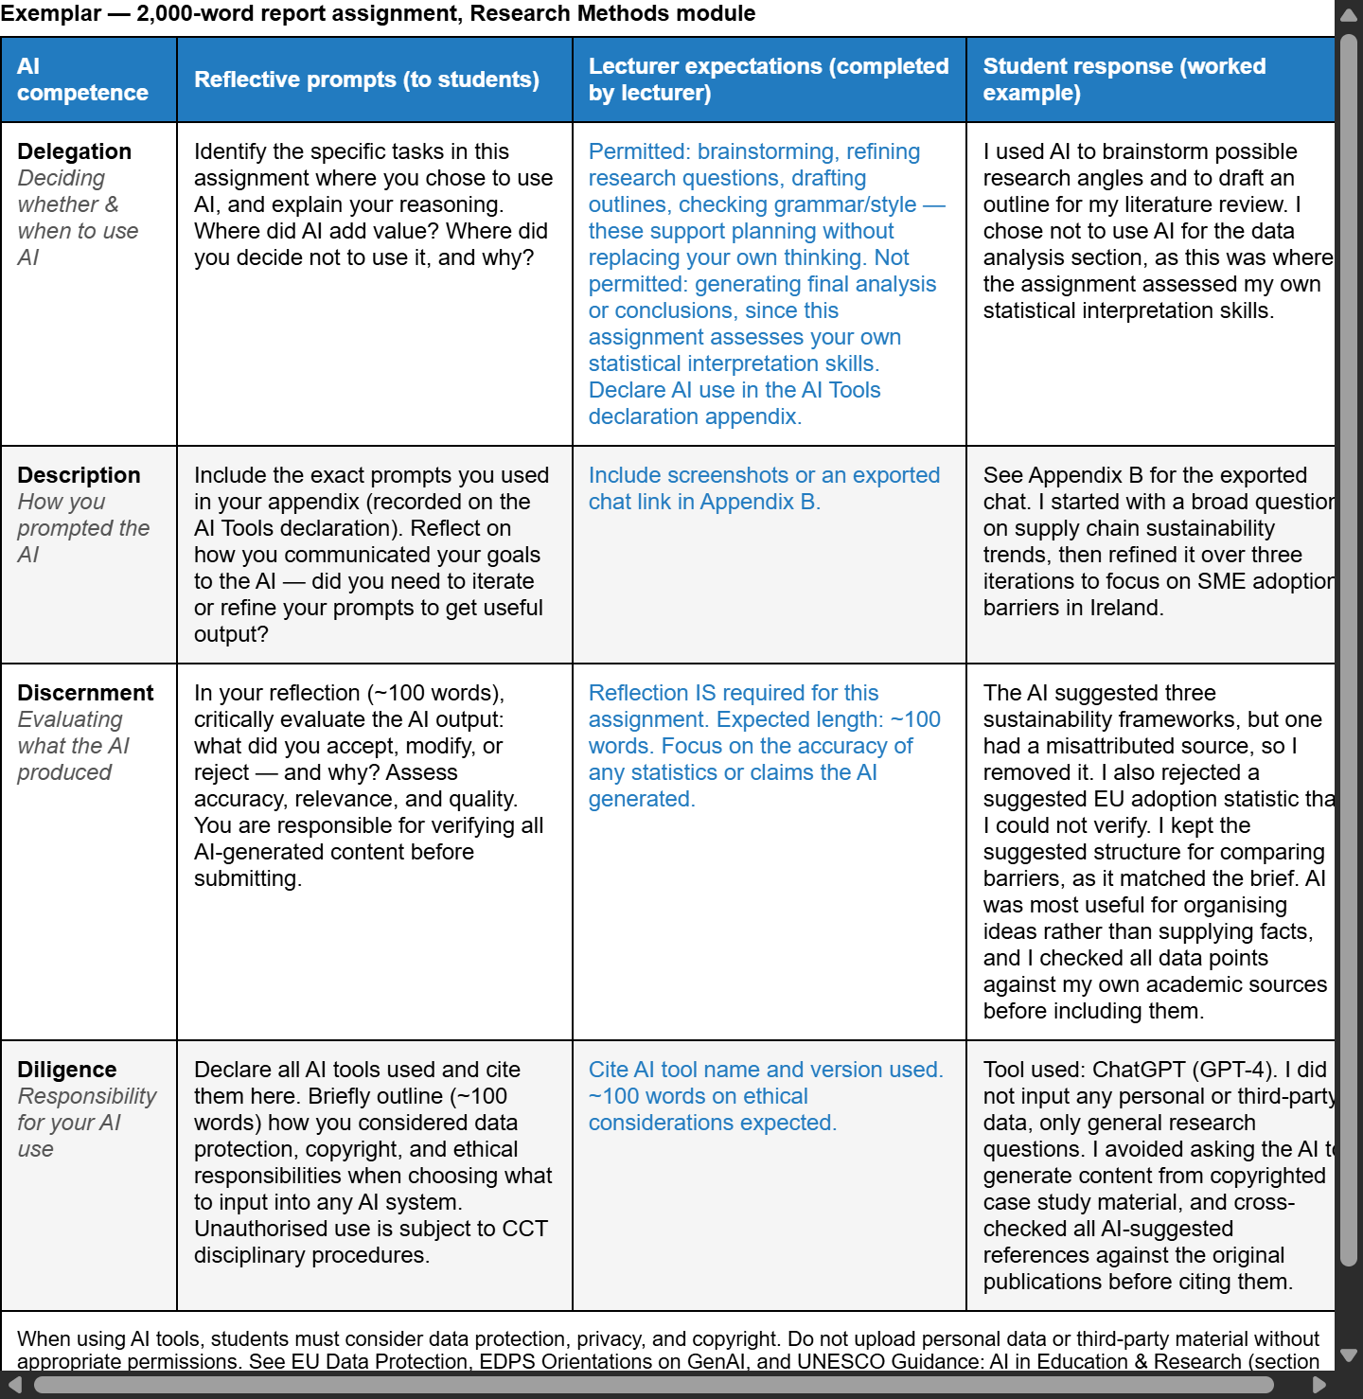

Note ALL Students are required to use GitHub for any Assignments that they are working on. You must Create your own Github Repository USING ONLY your CCT email (any other repo will not be accepted inc personal accounts and provide access to all the relevant lecturers)

All Project files MUST be uploaded into MOODLE, this is your responsibility, if any files are not uploaded to MOODLE, even if they are available on GITHUB, they will NOT BE GRADED. You may be called to a Viva to defend your work

This means that ALL changes must be committed to the assignments Git classroom during your assignment. (Not just a single commit at the end!) This is to allow you to display your incremental progress throughout the assessments, give you practice for your capstone/thesis, allows you to create an online portfolio that can be used to showcase your work and to ensure that there are no problems with final uploads (as all your work will be available on GitHub). It is expected that there will be a minimum of 10 commits (with many of you making very many more).
You may Only use your CCT email for your git account, private/work email-based accounts will not be accepted.

Students are advised to review and adhere to the submission requirements documented after the assessment task.

Additional Information
- Lecturers are not required to review draft assessment submissions.
- In accordance with CCT policy, feedback to learners may be provided in written, audio or video format and can be provided as individual learner feedback, small group feedback or whole class feedback.
- Results and feedback will only be issued when assessments have been marked and moderated / reviewed by a second examiner.
- Additional feedback may be requested by contacting your lecturer AFTER the publication of results, Additional feedback may be provided as individual, small group or whole class feedback. Lecturers are not obliged to respond to email requests for additional feedback where this is not the specified process or to respond to further requests for feedback following the additional feedback.
- Following receipt of feedback, where a student believes there has been an error in the marks or feedback received, they should avail of the recheck and review process and should not attempt to get a revised mark / feedback by directly approaching the lecturer. Lecturers are not authorised to amend published marks outside of the recheck and review process or the Board of Examiners process.
- Students are advised that disagreement with an academic judgement is not grounds for review.
- For additional support with academic writing and referencing students are advised to contact the CCT Library Service or access the Essentials Modules in Moodle.
- For additional support with subject matter content students are advised to contact the CCT Student Mentoring Academy
- For additional support with IT subject content, students are advised to access the CCT Support Hub.

Grading Criteria
This grading rubric sets out the marking criteria for your assessment.
Criteria | Screencast and Practical Code Example Big Data AND Neural Networks | Overview & State of the Art Big Data AND Neural Networks | Literature Review Big Data AND Neural Networks | Critical Evaluation Big Data AND Neural Networks | Conclusions Big Data AND Neural Networks
Weighting per criteria | 20 marks | 10 marks | 20marks | 40 marks | 10 marks
Excellent (+70%) | Clear, professional presentation; demonstrates practical deployment effectively; shows dataset handling and code execution; logical flow; fully accessible; 5–7 min. | Comprehensive coverage of chosen topic; clearly defined objective & research question; excellent synthesis of current methodologies and key research papers; logical structure. | Thorough review of relevant literature; demonstrates critical thinking; identifies trends, gaps, and key insights; accurate and complete Harvard referencing; well-organized. | Sophisticated analysis of key findings; identifies implications, limitations, contradictions, and research gaps; demonstrates deep understanding; presents original insights. | Logical, insightful conclusions strongly supported by research; demonstrates contribution, relevance, and potential future work.
Very Good (60 - 69%) | Mostly clear & structured; demonstrates code and dataset use; minor gaps in explanation or flow; accessible. | Clear objective & research question; good overview of methodologies & key research; may lack depth in analysis or connections. | Good coverage of key literature; some critical analysis; minor gaps in synthesis; mostly correct Harvard referencing. | Good analysis of findings and limitations; recognizes some gaps or contradictions; generally clear understanding. | Clear conclusions; generally consistent with research; minor lack of insight or innovation.
Good (50 - 59%) | Adequate explanation but may lack clarity, technical depth, or smooth flow; partially accessible; minor omissions. | Basic overview; research question present but vague; state-of-the-art review largely descriptive; limited synthesis. | Adequate coverage but mostly descriptive; limited critical engagement; some referencing errors. | Limited evaluation; mostly descriptive; weak identification of limitations, gaps, or contradictions. | Basic conclusions; mostly summary of findings; minimal critical insight.
Acceptable (40 - 49%) | Limited or unclear demonstration; minimal explanation of code/dataset; poorly structured; some accessibility issues. | Minimal or vague overview; unclear objective; superficial discussion of methodologies or key research. | Sparse review; mostly descriptive; minimal analysis; referencing inconsistent or incomplete. | Minimal evaluation; superficial discussion; poor awareness of limitations or implications. | Weak or vague conclusions; poorly linked to research findings.
Fail (< 39%) | Missing, inaccessible, or very poor demonstration; no meaningful explanation of work. | Absent or irrelevant; no clear objective or research question; no meaningful discussion of state-of-the-art. | Very limited or missing literature review; little or no analysis; incorrect or missing referencing. | Absent or seriously flawed evaluation; no analysis of findings or research gaps. | Absent or irrelevant conclusions; no connection to research findings.

